FIRST TERMINAL EXAMINATION-2019-20
MATHEMATICS
Class: VI Max Marks: 80
Date: 25.09.19 Time: 3 hrs
I FILL IN THE BLANKS: (6 x 1 = 6)
1) The predecessor of the smallest 4- digit number is ____.
2) The symbol C in a roman numeral can be subtracted from the symbols _____ and ____ only.
3) The LCM of two consecutive numbers is equal to ____.
4) _______ is a factor of every number.
5) A set of 3 consecutive prime numbers differing by 2 is called a ____.
6) For whole numbers, ____ is the additive identity.
II ANSWER THE FOLLOWING: (6 x 2 = 12)
7) Estimate the sum (62+45) to the nearest ten.
8) Name the properties used in the following:
(a) 36 + (54 + 25) = (36 + 54) + 25
(b) 6 x 15 = 15 x 6
9) List all the multiples of 5 between 70 and 100
10) Find the HCF of 30 and 84.
OR
Find the prime factorization of 540

11) Draw a line segment of length 6.5 cm using a ruler.
12) Write the smallest and the greatest 2- digit prime number.
III ANSWER THE FOLLOWING: (10 x 3 = 30)
13) Use the digits 3, 0, 9 and 7 without repetition, and make the greatest and the smallest 4-digit numbers.
14) An aero plane covers 850 km in 1 hour. How much distance will it cover in73 hours?
15) Is 2755896 divisible by 11? Use the test of divisibility to solve.
OR
Express the following numbers as sum of twin primes
(a) 36 (b) 24 (c) 120
16) Evaluate 3 X 5 using a number line
17) Find the sum of 23456 + 9999 by using a short method.
18) (a) Find two numbers whose difference is 13 and product is 48.
(b) A number is divisible by 16. By what other numbers will that number be divisible?
19) Write the smallest 4-digit number and express it in terms of its prime factors.
20) The students of a class can be divided into groups of 2, 3, 4 and 5. What is the least number of students this class can have?
21) Complete the figures treating the dotted line as the line of symmetry.
(a) (b) (c)
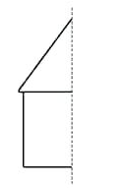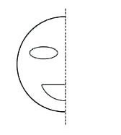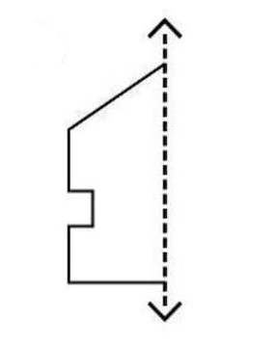

22) Draw a circle of radius 4.8 cm. Write the steps for construction.
IV ANSWER THE FOLLOWING: (8x4=32)
23) With the same centre, draw two circles of radii 4 cm and 6 cm, respectively. Mark points A, B and C such that
(a) A is on the smaller circle
(b) B is on the exterior of both the smaller and larger circles.
24) Write the number names of the following in the Indian system of numeration as well as in the International system of numeration.
(a) 30570832 (b) 564500024
25) Verify that the product of 48 and 60 is equal to the product of their LCM and HCF.

26) Three bells toll at intervals of 4, 7 and 14 minutes respectively. All the three bells tolled together at 6 a.m. When will they next toll together?
27) (a) Find the value of 932 x 103 (Use the distributive property)
(b) Find the sum of 876 + 305 + 524 by suitable arrangement
28) (a) Find the number of lines of symmetry in each of the following.
(1) (2)

(b) Draw the lines of symmetry
(1) (2)
29) In a school there are twelve classes. If each class has 28 boys and 22 girls, find the number of students enrolled in the school .
30) A car travels 868 km in 14 hours. What is the average speed of the car.

